Test Case: 01_CCP-6072_Notification succesfully completed enrollment process_SMS_Chrome
URL: https://sit.banamexsoaproxy1.intranet.banamex.com/uat2ps/banamex-cards-es/login
Credit Card Name: ZYYYYXX ZZZZYYZXXXXZ
Credit Card Number: 5288430440685197
CVV: 119
Exp Date: 04/21
DOB: 01/01/1980

Step 1:

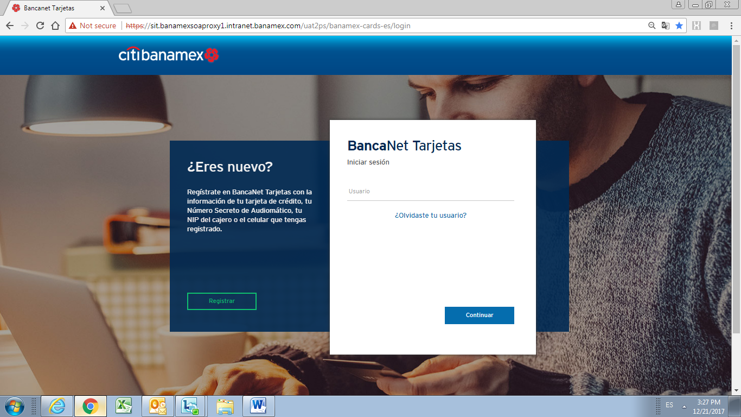

Step 2:

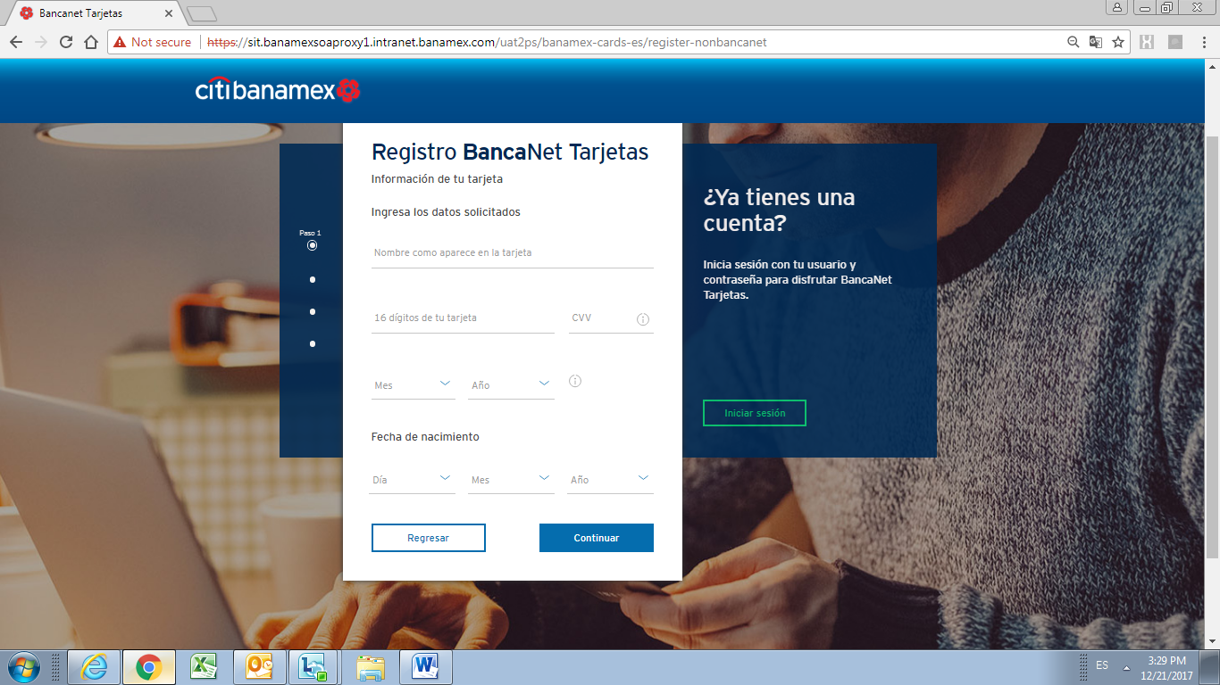

Step 3:

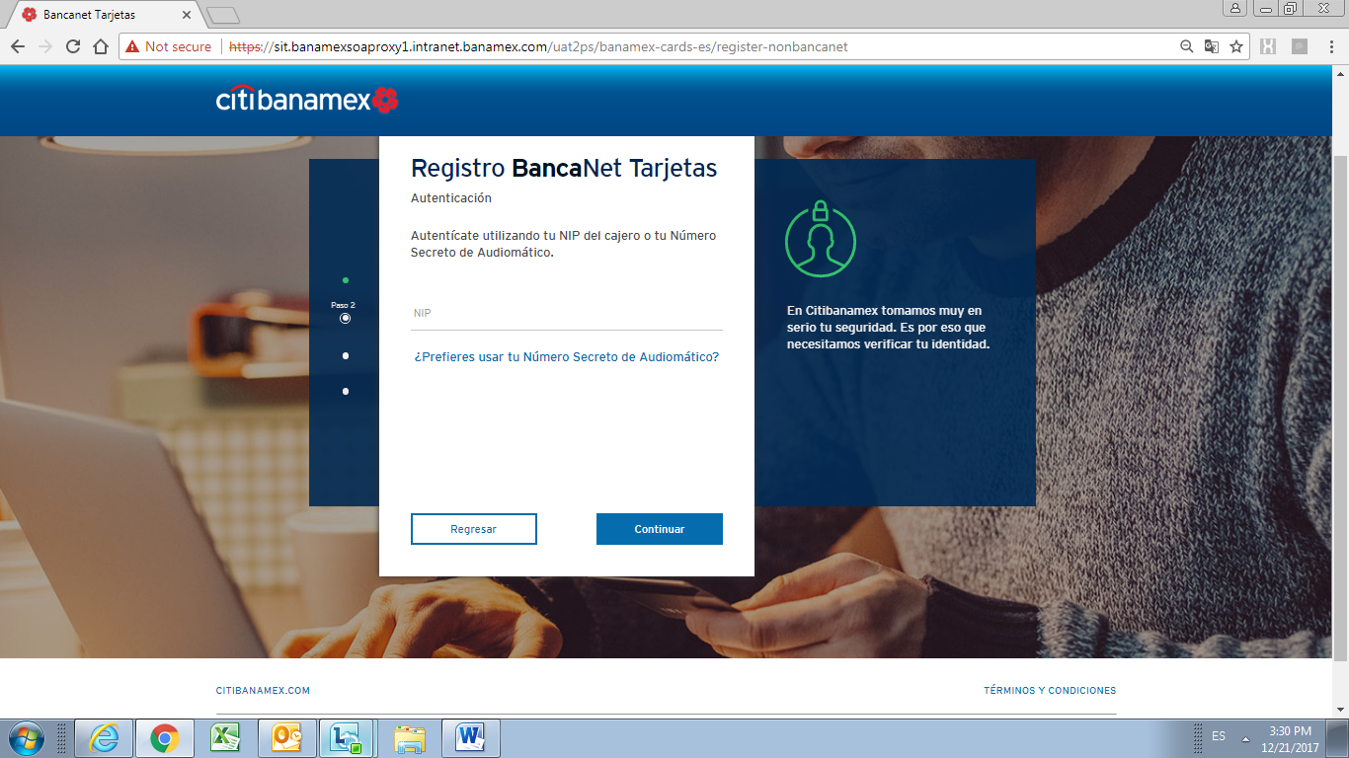

Step 4:

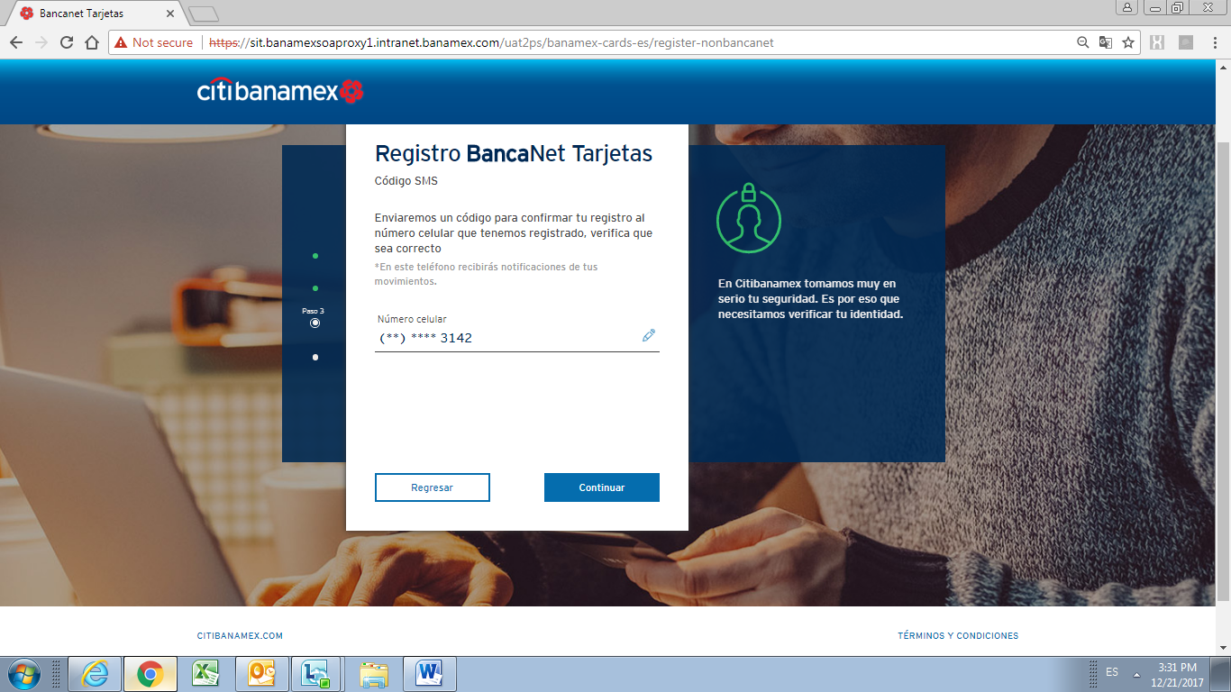

Step 5:

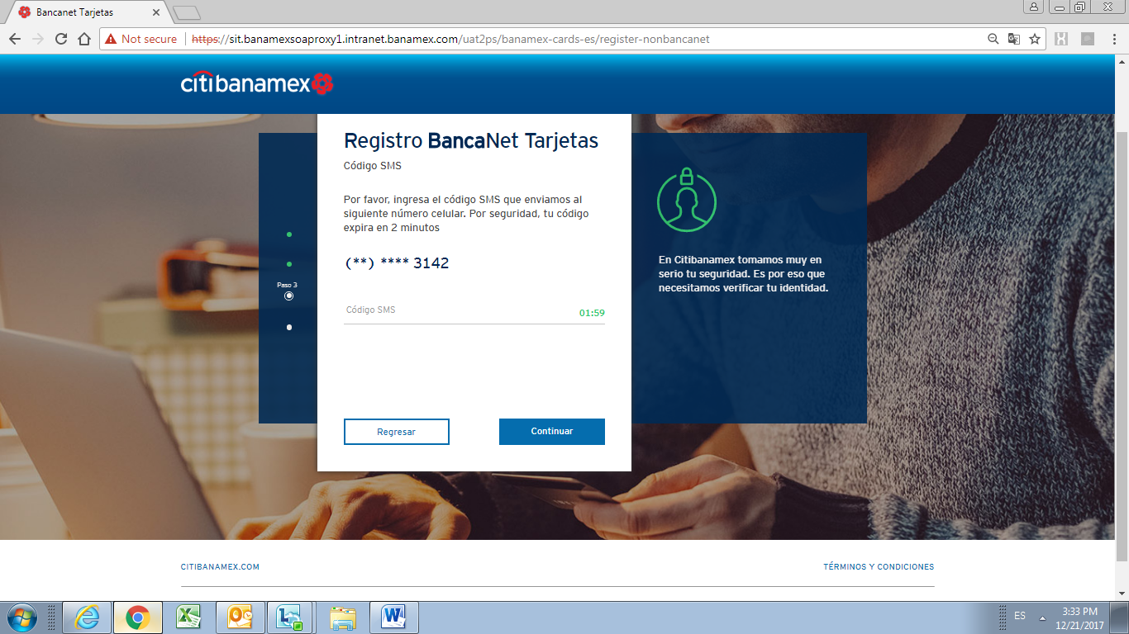

Step 6:

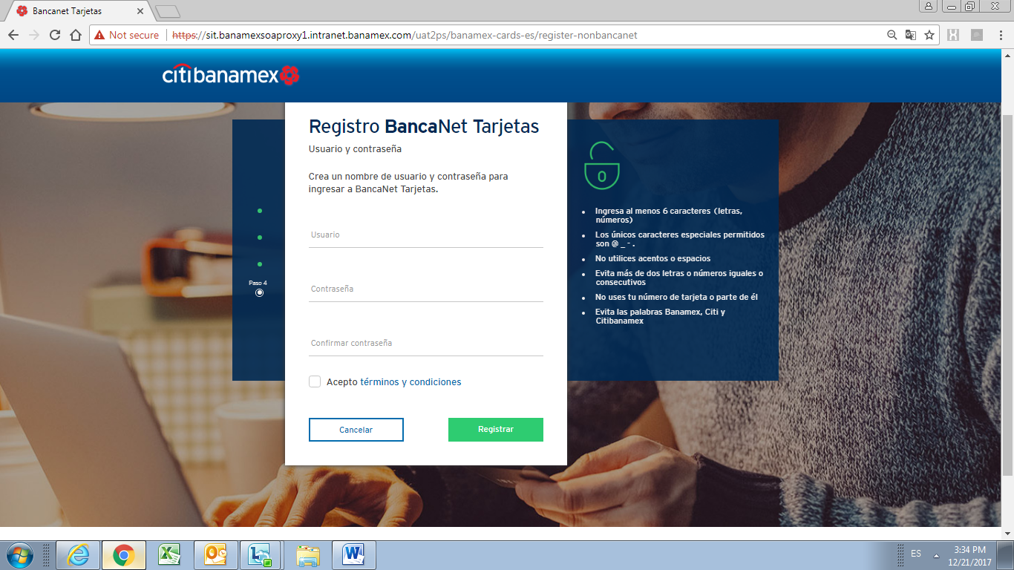

Step 7:

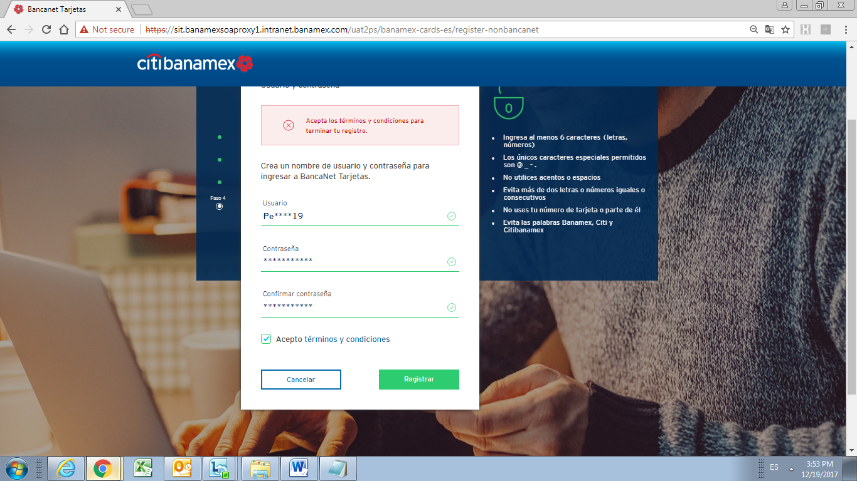

Step 8:

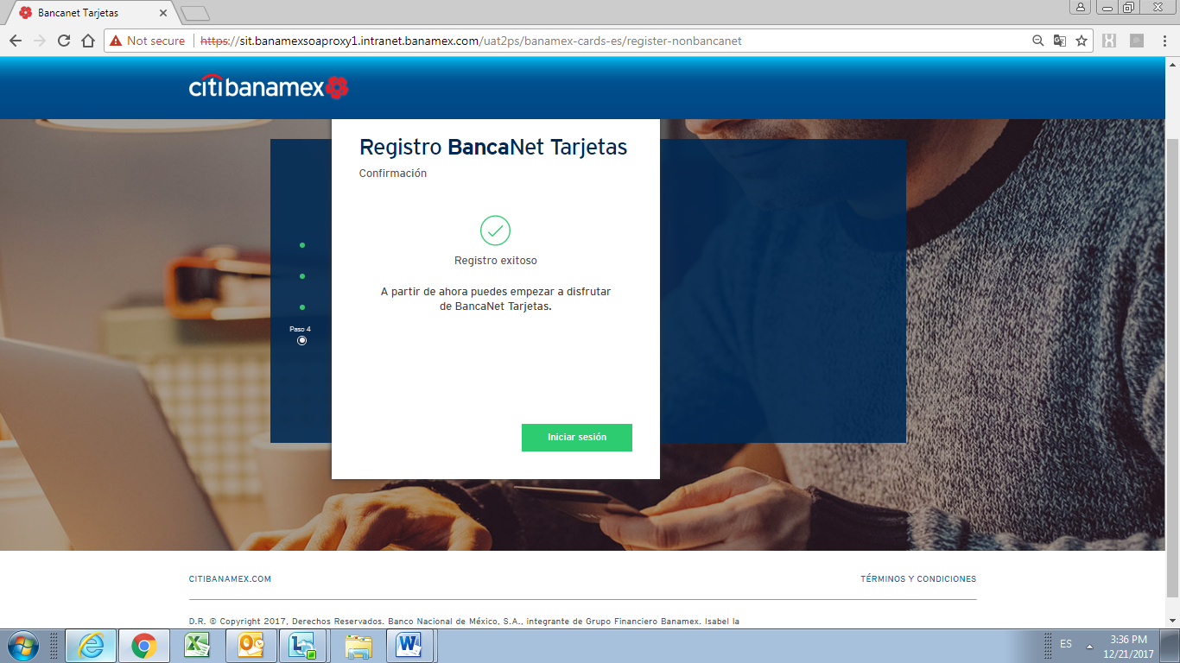

Step 9:

